WEEK 1
DATA SCIENCE ORIENTATION
& PROBLEM DEFINITION
Project: Exploring Customer Feedback and Product Sentiment

Student Name | Sumit Kumar
Internship | Data Science with Python Analyst Internship
Project Domain | Beauty and Wellness
Submission Date | 02 October 2026
Tools | Python, Visual Studio Code, GitHub
WEEK 1 SUBMISSION REPORT

1. Introduction
This report documents the Week 1 orientation and problem-definition work for a Data Science with Python Analyst Internship project in the Beauty and Wellness domain. The proposed project, “Exploring Customer Feedback and Product Sentiment,” establishes a business problem and a plan for subsequent data analysis.
This submission covers project framing, research questions, proposed methods, and verification of the local Python development environment. No customer dataset has yet been analyzed, and no sentiment findings or model-performance results are claimed.

2. Project Overview
Project title: Exploring Customer Feedback and Product Sentiment
Domain: Beauty and Wellness
Project concept: Explore customer review text for recurring themes and sentiment, provided a suitable dataset is identified and its use is permitted.

3. Business Problem Definition
Beauty and wellness products may receive customer feedback across multiple review channels. When feedback is available in large volumes, manually reviewing every comment can make it difficult to consistently identify recurring concerns, appreciated product attributes, and areas for further investigation. The proposed data-science task is to organize and examine review text so patterns can be summarized in a structured way.
This is a proposed problem statement. Its scope and feasibility will be refined after confirming the availability, quality, permissions, and fields of an appropriate dataset.

4. Project Objectives
- Define a focused customer-feedback problem in the Beauty and Wellness domain.
- Identify suitable data fields, such as review text, product category, rating, and review date, if available.
- Plan a reproducible workflow for data inspection, cleaning, exploratory analysis, and sentiment exploration.
- Document assumptions, data limitations, and ethical considerations before analysis.
- Prepare the Python environment and repository for later practical tasks.

5. Initial Research Questions
- What recurring topics or product attributes appear in the available customer reviews?
- What sentiment categories can be explored from review text using a suitable, documented method?
- If ratings are present, how do rating distributions relate to review themes or sentiment categories?
- What data-quality issues, such as missing text, duplicate records, or inconsistent fields, need to be addressed?

6. Scope and Limitations
Proposed scope:
- Review a suitable, permitted dataset related to beauty and wellness products.
- Inspect available columns and assess completeness and consistency.
- Clean and prepare relevant fields for analysis.
- Produce exploratory summaries and visualizations; explore sentiment only if supported by the data.
Current limitations:
- No customer dataset has been analyzed for this Week 1 report.
- The data source, sample size, language, and representativeness remain to be confirmed.
- Sentiment labels and model results will not be reported until the method is implemented and evaluated.
- Any later conclusions will be limited to the dataset and its documented collection context.

7. Proposed Methodology
- Data sourcing: identify a suitable dataset and check its license, permitted use, provenance, and documentation.
- Data inspection: review rows, columns, data types, missing values, duplicates, and basic distributions.
- Preprocessing: clean relevant text and standardize fields as appropriate, documenting transformations.
- Exploratory analysis: summarize review counts, ratings, categories, and common terms where supported.
- Sentiment exploration: apply an appropriate documented method after selecting the data and approach.
- Evaluation and reporting: assess limitations, validate outputs where possible, and avoid overstating generalizability.

8. Tools and Technologies
The workspace is being prepared with Python and Visual Studio Code. GitHub is used for version control and sharing project documentation and code.
- Python 3.14.6
- Pandas 3.0.6
- NumPy 2.5.3
- Matplotlib 3.11.2
- Seaborn 0.13.2
- Visual Studio Code and GitHub

9. Python Environment Setup and Verification
A Python script named week1_setup.py was created to import the required libraries and print their version information. The script was executed successfully in Visual Studio Code. The observed execution completed with exit code 0 and printed “Project Environment Setup Successful!”
Screenshot evidence is stored at Week-1/screenshots/environment_setup.png. This script verifies the local environment only; it does not perform customer-data analysis.

Screenshot Evidence: Python Environment Setup
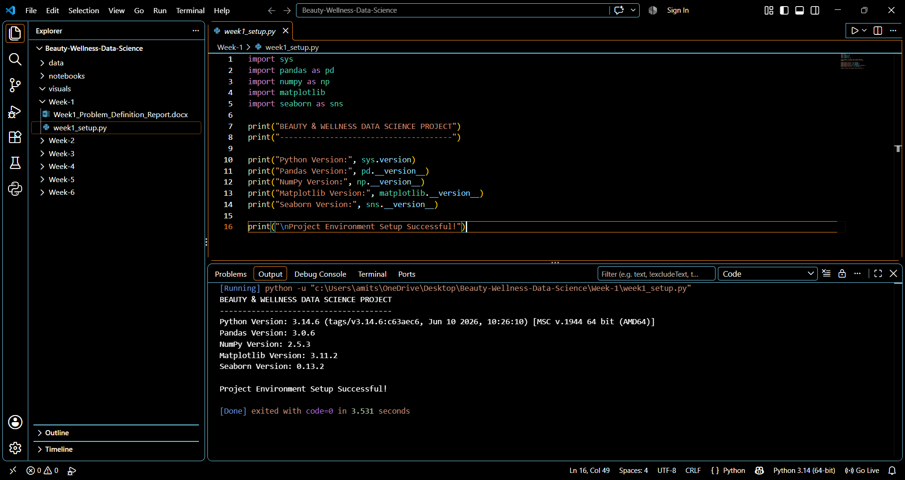
Figure 1. Successful execution of week1_setup.py in Visual Studio Code, showing installed library versions and exit code 0.

10. Week 1 Deliverables
- Problem-definition report (this document).
- Week 1 README documentation.
- Python environment verification script (week1_setup.py).
- Environment setup screenshot evidence (screenshots/environment_setup.png).

11. Conclusion and Next Steps
Week 1 established the project direction, initial business problem, objectives, research questions, scope, and proposed methodology. The local Python environment was configured and verified. The next stage is to identify and validate a suitable dataset, document its source and permitted use, and begin structured data inspection before drawing conclusions about customer sentiment.

12. References and Data Provenance
No external dataset or research source is cited because a specific dataset has not yet been selected. The source, license, and documentation of any dataset used in later weeks should be recorded in the relevant report and repository README.

